**DEPARTMENT OF COMPUTER ENGINEERING**

**GOVERNMENT POLYTECHNIC, AWASARI (KH)**

**SEMESTER VI [2018-2019]**



**A**

**PROJECT REPORT**

**ON**

**“AwareBot to enhance students’ productivity”**

Submitted by:

Sagar Ravindra Labade 18CO337

Naikade Rohit Anand 18CO334

Inamdar Yasar Raju 18CO311

UNDER THE GUIDANCE OF

Mrs. Dandale Madam

**DEPARTMENT OF COMPUTER ENGINEERING**

**GOVERNMENT POLYTECHNIC, AWASARI (KH)**

**SEMESTER VI [2018-2019]**



**CERTIFICATE**

This is to certify that project work entitled

**Android app and website “AwareBot” for College students to enhance productivity**

Submitted by:

1. Sagar Ravindra Labade 18CO337
2. Naikade Rohit Anand 18CO337
3. Inamdar Yasar Raju 18CO337

is a bonafide work carried out under the supervision of Mrs. Dandale and it is submitted towards the partial fulfillment of the requirement of MSBTE, for the award of the Diploma in Engineering (Computer Engineering).

(Mrs. Dandale) (Mrs. Sant S.S.)

**Guide (Internal Examiner) Head of Computer Department**

**External Examiner**

**Place:** Awasari (Kh), Pune **Date:**

**ABSTRACT**

**Project Topic: ‘AwareBot’ to enhance students’ productivity**

We present a system that enhances productivity of college students. In this system, website and android application is used. Our system is used to give updates to students directly from teachers in their hands anytime, anywhere. Here, when teacher’s login takes place successfully he/she is directed to activity to enter some data about lectures, notices and so on. When students get logged into the system they can see the posts posted by their corresponding teachers. By this mechanism both teachers and students save lot of time and efforts.

For logging in, we provide permissions to teachers to assign different passwords for different classes. If students do not have android, then they can use our website to see posts. This website is developed for apple iPhone or desktop users.

To implement this, we have used realtime database which allows to store and retrieve data in milliseconds. This makes our system more responsive and reliable.

**ACKNOWLEDGMENT**

I have great pleasure and sense of satisfaction in presenting this project report on “AwareBot to enhance students’ productivity”.

As part of the curriculum of diploma in Computer Engineering. I am very fortunate to be guided by people with vast and resourceful experience in their respective field of work

I express my sincere gratitude to my guide Mrs. Dandale (Lecturer in computer Engineering department) for her timely guidance, support and suggestions. I am also thankful for her sincere help and for making me available all the faculty of the department. Without their efforts and constants monitoring the project and documentation would not have been duly completed. Also, I express my sincere thanks to Mrs. Sant S. S. (HOD of computer department), besides, I take this opportunity to express my sincere gratitude to the principal Dr. S. R. Kerkal, G.P. Awasari for providing a good environment and facilities to complete this project. I would also like to thanks all my colleagues who have directly or indirectly guided and helped me in the preparation of this project.

**CONTENTS**

|  |  |  |
| --- | --- | --- |
| **Chapter** | **Name of the topic** | **Page No** |
| **1** | **Introduction**   * 1. Android   2. Problem statement   3. Project objectives |  |
| **2** | **Feasibility Study**  2.1 Technical feasibility  2.2 Time feasibility  2.3 Economical feasibility |  |
| **3** | |  | | --- | | **Requirement Analysis** | | 3.1 Software requirements  3.2 Hardware requirements | |  |
| **4** | **Project Planning**  4.1 Efforts  4.2 Time estimation  4.3 Cost estimation of the project  4.4 Work structure |  |
| **5** | **Project Schedule**  5.1 Project work break down structure  5.2 Team structure  5.3 Task and Milestone |  |
| **6** | **Project Design**  6.1 Architecture block diagram  6.2 Data Flow Diagram  6.3 Use Case Diagram |  |
| **7** | **System behavioral Description**  7.1 State transition diagram  7.2 E-R diagram |  |
| **Chapter** | **Name of the topic** | **Page No** |
| **8** | **Project Implementation Testing**  8.1 Classes of test  8.2 Test cases  8.3 GUI implementation (SNAPSHOT)  8.4 Database designing |  |
| **9** | **Conclusion and Future Scope** |  |
| **10** | **Reference** |  |
| **11** | **Appendix** |  |

**LIST OF FIGURES**

|  |  |  |
| --- | --- | --- |
| **Sr. No.** | **Name of figure** | **Page No.** |
|  |  |  |
|  |  |  |
|  |  |  |
|  |  |  |
|  |  |  |
|  |  |  |

**LIST OF DIAGRAMS**

|  |  |  |
| --- | --- | --- |
| **Sr. No.** | **Name of figure** | **Page No.** |
|  |  |  |
|  |  |  |
|  |  |  |
|  |  |  |
|  |  |  |
|  |  |  |
|  |  |  |

**Chapter 1: INTRODUCTION**

The android operating system is basically an operating system for mobiles. It is mobile operating system that uses a modified version of the Linux kernel 2.6. Google developed Android as part of the Open Handset Alliance, a group of more than 30 mobile and technology companies working to open up the mobile handset environment. In this, it will be described that how security can be improving of Android Operating System so that users can safely use the android smart phones. Keywords: -Android history, architecture and security

**1.1 ANDROID:**

**HISTORY OF ANDROID:**

Android Inc. Founded in Palo Alto, California, united states in October 2003 by Andy Rubin [co-founder of danger], rich miner [co-founder of wildfire communication Inc.], nick sears [once VP at T-Mobile], and Chris white [headed design and interface development at web TV] to develop.

**WHAT IS ANDROID:**

Android Inc. Founded in Palo Alto, California, united states in October 2003 by Andy Rubin [co-founder of danger], rich miner [co-founder of wildfire communication Inc.], nick sears [once VP at T-Mobile], and Chris white [headed design and interface development at web TV] to develop.

**ANDROID VERSION:**

1. Android 1.0 (Angel Cake)-The first version of the open source software was released back in 2008.
2. Android 1.1 (Battenberg)-In Feb 2009, version 1.1
3. Android 1.5 (Cupcake)-Launched in April 2009
4. Android 1.6 (Donut)-released in September 2009
5. Android 2.0/ 2.1 (Éclair)-released in 26th October 2009 and January 2010
6. Android 2.2 (Froyo) –frozen yoghurt - Released in the summer of 2010
7. Android 2.3 (Gingerbread) - Gingerbread landed by the end of 2010
8. Android 3.0 (Honeycomb) - For the first time Google released a software that was totally focused on tablets. This version, released in July/august 2011
9. Android 4.0 (Ice Cream Sandwich 4.0)-released in October 2011
10. Android 4.1 (jelly bean4.1) -released in 26th June 2012
11. Android 4.4 (KitKat) - released on October 2013.
12. Android 5.1 (Lollipop) – released on November 12, 2014
13. Android 6.0 (Marshmallow) – released on October 5, 2015
14. Android 7.0 (Nougat) – released on August 22, 2016
15. Android 8.0 (Oreo) – released on August 21, 2017
16. Android 9.0 (Pie) – released on August 6, 2018Android 10.1 (Android Q)

After so many desserts named version of android is going to offer something with even tastier desserts and sweet dishes.

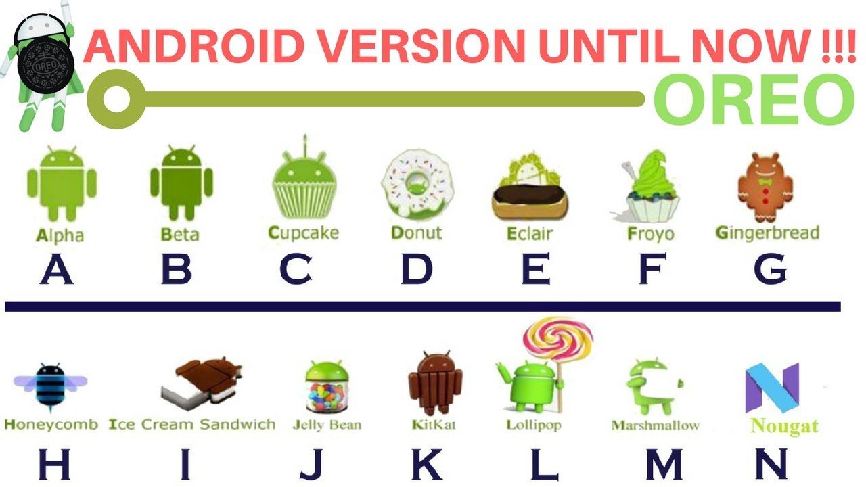

**ANDROID ARCHITECTURE**:

1. The software stack is split into Four Layers:
2. The application layer
3. The application framework
4. The libraries and runtime
5. The kernel

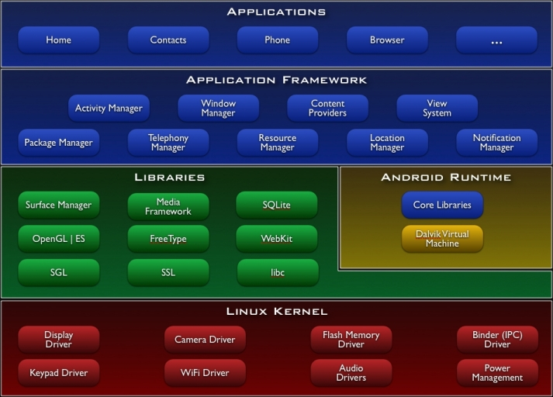

**FEATURES OF ANDROID:**

1. Background Wi-Fi location still runs even when Wi-Fi is turned off.
2. Developer logging and analyzing enhancements
3. It is optimized for mobile devices.
4. It enables reuse and replacement of components.
5. Java support, media support, multi touch, video calling, multi-tasking, voice based features, screen capture, camera, Bluetooth, GPS, compass and accelerometer, 3G, 4G.

**ADVANTAGES:**

* The ability for anyone to customize the Google Android platform

1. It gives you better notification.
2. It lets you choose your hardware.
3. It has better app market (1,80,000 application)
4. A more mature platform
5. With the support of many applications, the user can change the screen display.
6. With Google chrome you can open many windows at once.
7. Supports all Google services: Android operating system supports all of Google services ranging from Gmail to Google reader. All Google services can you have with one operating system, namely Android.

**DISADVANTAGES:**

Android Market is less control of the manager, sometimes there are malware. Wasteful Batteries, this is because the OS is a lot of "process" in the background causing the battery quickly drains. Sometimes slow device company issued an official version of Android your own. Extremely inconsistence in design among apps. Very unstable and often hang or crash.

**LIMITATIONS OF ANDROID:**

Development requirements in Java - Android SDK

Android doesn't support:

1. Bluetooth stereo.
2. Contacts exchange.
3. Modem pairing.
4. Wireless keyboards
5. Photoshop mobile isn't coming to android because of android limitations.
6. Apps Android Market need to be programmed with a custom form of Java There are no split or interval times available.
7. Small memory size.
8. Continuous Internet connection is required

**1.2 Problem Statement:**

1. Students waste time on attending to off lectures.
2. Students don’t know ‘what’s going on in their college’.
3. They don’t attend every lecture.
4. They don’t know syllabus of their subjects.
5. They don’t do regular study.
6. They don’t take benefits of e-learning and smart study.

**1.3 Project Objectives:**

1. Save time.
2. Save efforts.
3. Increase productivity
4. Smart study
5. Learn before attend
6. Build interest in learning

**Chapter 2: FEASIBILITY STUDY**

**2.1 TECHNICAL FEASIBILITY STUDY:**

This assessment is based on an outline design of system requirements, to determine whether the company has the technical expertise to handle completion of the project. When writing a feasibility report, the following should be taken to consideration:

1. A brief description of the business to assess more possible factors which could affect the study
2. The part of the business being examined
3. The human and economic factor
4. The possible solutions to the problem

At this level, the concern is whether the proposal is both technically and legally feasible (assuming moderate cost).

The technical feasibility assessment is focused on gaining an understanding of the present technical resources of the organization and their applicability to the expected needs of the proposed system. It is an evaluation of the hardware and software and how it meets the need of the proposed system.

**2.2 TIME FEASIBILITY:**

A time feasibility study will take into account the period in which the project is going to take up to its completion. A project will fail if it takes too long to be completed before it is useful. Typically, this means estimating how long the system will take to develop, and if it can be completed in a given time period using some methods like payback period. Time feasibility is a measure of how reasonable the project timetable is. Given our technical expertise, are the project deadlines reasonable? Some projects are initiated with specific deadlines. It is necessary to determine whether the deadlines are mandatory or desirable.

**CHAPTER 3: REQUIREMENT ANALYSIS**

**3.1 FUNCTIONAL REQUIREMENTS:**

**3.1.1. Observation:**

“AwareBot” is an application which allows both students and teachers to be aware about everything about their need. It allows teachers to share urgent notifications to their students. Data shared at each minute by teachers could become very helpful to students as it contains information which make students productive and very smart.

**3.2 SOFTWARE REQUIREMENT**:

1. **Technologies** : Java, XML
2. **Database** : Firebase Realtime Database
3. **Operating System** : Microsoft® Windows® 7/8/10 (32 or 64 bit)
4. **Application Software** : Android studio
5. **Tools**  : SDK
6. **Drivers** : ADB, SDK

**3.3 HARDWARE REQUIREMENT:**

1. **RAM**  : 3 GB RAM minimum, 8 GB RAM recommended; plus 1 GB for the Android Emulator
2. **Hard disk** : 2 GB of available disk space minimum, 4 GB Recommended (500 MB for IDE + 1.5 GB for Android SDK and emulator system image)
3. **Resolution** : 1280 x 800 minimum screen resolution

**3.3 SOFTWARE REQUIREMENT FOR WEBSITE**:

1. **Technologies** : HTML, CSS, JAVASCRIPT
2. **Database** : Firebase Real-time Database
3. **Operating System** : Microsoft® Windows® 7/8/10 (32 or 64 bit)
4. **Application Software** : Visual Studio

**CHAPTER 4: PROJECT PLANNING**

**4.1 EFFORTS:**

We listed down following efforts to successfully complete our project:

1. Finding Project Topic
2. Finding Existing System and disadvantages
3. Finding solution
4. Collecting information
5. Implementing Proposed System
6. Developing GUI
7. Implementing database
8. Testing of Project

**4.2 TIME ESTIMATION:**

|  |  |
| --- | --- |
| **Tasks** | **Starting Period** |
| Requirement analysis | September 3rd week |
| Project Planning | October 3rd week |
| Design | November 3rd week |
| Development | December - Feb |
| Integration and testing | March 1st week |
| Execution and Deployment | March 3rd week |

Table 4.1 Time Estimation

**4.3 COST ESTIMATION OF THE PROJECT:**

To complete this project, before starting the planning phase, we studied about our project requirements. Then, we planned about what we would need to develop app and website. For completing it, we thought that we would not need any other resources to spend money other than our laptops and programming knowledge.

|  |  |  |
| --- | --- | --- |
| **Sr. No.** | **Description** | **Cost** |
| 1 | 2 laptops* | 0 ₹ |
| 2 | 2 chargers | 0 ₹ |
| 3 | Programming Knowledge Course-  Android application development | 3000 ₹ - 5000 ₹ |
| 4 | Programming Knowledge Course-  Web development | 1500 ₹ - 4000 ₹ |

* - Resources we already had.

₹ - Indian Currency (Rupee)

Table 4.2 Cost Estimation

So, our estimated cost was up to 4500 to 9000 rupees.

P

E

R

C

E

N

T

A

G

E

**4.4 WORK STRUCTURE:**

We estimated time to complete project. So, for avoid late delivery of our project each phase had to be completed in corresponding period.

As per time estimation, we developed bar graph to understand our work structure easily.

Diagram No. 4.1 Work Structure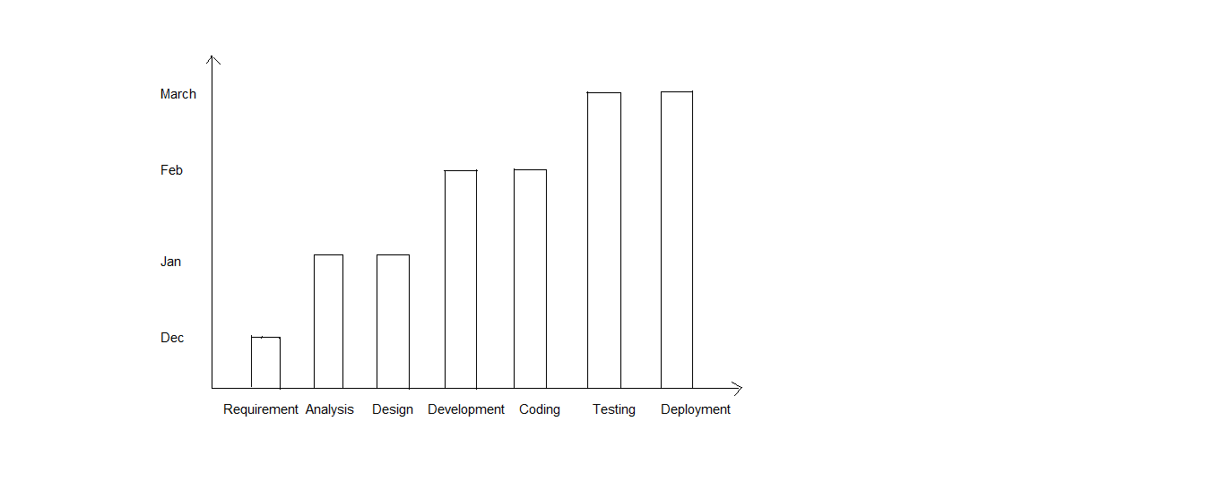

**4.4.1 Architecture**

After requirements gathering and calculating estimations, we need to develop “system architecture”. We knew that, Architecture diagram would help us visualize the high-level, overall structure of our system or application, in order to ensure the system meets our users' needs. Using architecture diagram, we could also describe patterns that are used throughout the design.

Some of the benefits of developing ‘system architecture’:

1. It gives a basis for analysis of software systems’ behavior before the system has been built. The ability to verify that a future software system fulfills its users’ needs without actually having to build it represents substantial cost-saving and risk-mitigation. A number of techniques have been developed to perform such analyses, such as ATAM.
2. It provides a basis for re-use of elements and decisions. A complete software architecture or parts of it, like individual architectural strategies and decisions, can be re-used across multiple systems whose stakeholders require similar quality attributes or functionality, saving design costs and mitigating the risk of design mistakes.
3. It supports early design decisions that impact a system's development, deployment, and maintenance life. Getting the early, high-impact decisions right is important to prevent schedule and budget overruns.
4. It helps in risk management. Software architecture helps to reduce risks and chance of failure.
5. It enables cost reduction. Software architecture is a means to manage risk and costs in complex IT projects.
6. For that, we studied about users who are involved

**Efforts needs to be done:**

1. Understand users in system.
2. Understand requirements
3. Understand Flow of data in system
4. Recognize technical resources

**4.4.2 ‘AwareBot’ architecture:**

We successfully developed system architecture as below:

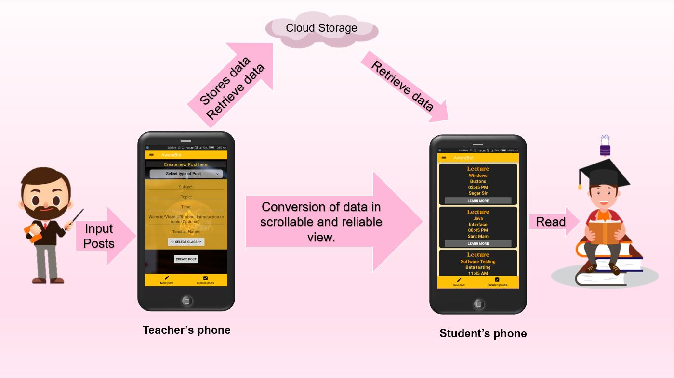

Diagram 4.2: ‘AwareBot’ architecture

**CHAPTER 5: PROJECT SCHEDULE**

**5.1 PROJECT WORK BREAK DOWN STRUCTURE:**

Dividing complex projects to simpler and manageable tasks is the process identified as Work Breakdown Structure (WBS).

Usually, the project managers use this method for simplifying the project execution. In WBS, much larger tasks are broken down to manageable chunks of work. These chunks can be easily supervised and estimated.

WBS is not restricted to a specific field when it comes to application. This methodology can be used for any type of project management.

Following are a few reasons for creating a WBS in a project:

1. Accurate and readable project organization.
2. Accurate assignment of responsibilities to the project team.
3. Indicates the project milestones and control points.
4. Helps to estimate the cost, time and risk.
5. Illustrate the project scope, so the stakeholders can have a better understanding of the same.

**‘AwarBot’ to enhance students’ productivity**

**T1: Requirement**

**Gathering**

**T2: Project**

**Planning**

**T5: Testing**

**T4: Coding**

**T3: System**

**Design**

**T1:** Task 1

**T2:** Task 2

**T3:** Task 3

**T4:** Task 4

**T5:** Task 5

**T3: Project Scheduling**

**T2: Project**

**Estimation**

**T1: System**

**Scope**

Diagram 5.1. Project Work Break Down Structure.

**5.2 Project Scheduling:**

Project scheduling is a mechanism to communicate what tasks need to get done and which organizational resources will be allocated to complete those tasks in what timeframe. A project schedule is a document collecting all the work needed to deliver the project on time.

Before going deeper into project scheduling, let’s review the fundamentals to project scheduling. Project scheduling occurs during the planning phase of the project. You have to ask yourself three questions to start:

1. What needs to be done?

2. When will it be done?

3. Who will do it?

Our project schedule was as below:

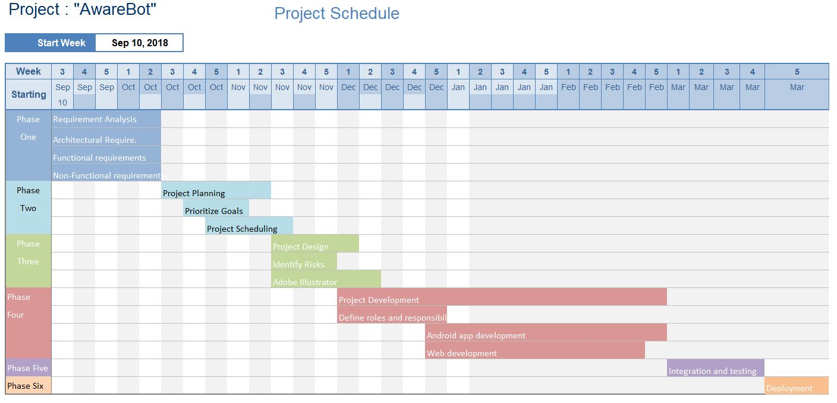

Diagram No. 5.1

**5.2 TASKS AND MILESTONE:**

T1: Project topic searching

T2: Project Topic Selected

T3: Preparing and submitting synopsis

T4: Preparing presentation for selected topic

M1: Project Finalized

M2: Requirement analysis for the project

T5: Deciding Modules, model for implementation

M3: Requirement Analysis and Functional Requirement

T6: Preparing Report of project

M4: Modelling and Project Report Complete

T7: Implementation of project begins

**CHAPTER 6: PROJECT IMPLEMENTATION**

**6.1 DETAILED WORKING OF PROJECT:**

The project illustrated in this paper is entirely based on the idea of increasing productivity of college’s students and teachers. Teachers send posts after entering some data into in. Posts are classified as per their audience such as first year, second year and third year (students). That means, if teachers create post for first year students then application provides option to select post audience, and only first year students would be able to read the posts.

Our application provides security to both teachers and students. Which enables teachers to enter password to use application features. This will stop data temper. Also these passwords will be checked through database. Even someone knows password, it will be changed from database. Also students need passwords to enter into system. These passwords are managed by teachers. They can change it or see it.

We implemented some types of posts as result of teachers’ requirements. These types help teachers to easily fill data and submit into database.

They are as below:

**6.1.1 LECTURE**

Whenever teachers want to conduct their lectures, they have to make post related to it for specific audience. Due to this student get alert. Sometimes they don’t know which lecture is going to take place. So, they bunk lectures. And they miss important lectures. So, this section will help students to easily decide whether to attend it or not. Also we provided feature to “Learn More” option which will redirect student to website or video where he can learn on internet and easily generate interest in it. This will reduce his efforts for studying later. Also, many students don’t study until exams come near. But they can watch at least two to three videos per day and learn something. So, this feature will generate interest in learning. “Teaching” becomes easy for teachers and “learning” becomes easy for students.

Fields related to Lecture:

1. **Subject**: Subject which teacher is going to teach
2. **Topic**: Topic in that subject which teacher going to teach
3. **Time**: Time on which lecture would start
4. **Website**/**Video** **URL**: Website or YouTube video link of that topic
5. **Teacher** **Name**: Name of teacher who is sending that post.

**6.1.2: OFF-PERIOD:**

If teachers are not conducting lecture, they can use this option to enter data in application. This will save students’ lot of time, and efforts. Some students come to college from long distances for attending specific lecture or difficult lectures. Sometimes, teachers have some other important works on same lecture time. So, it could become annoying for any student. To overcome this problem, which we also faced lot of time, our application helps a lot.

Teacher just has to create post of ‘Off-period’, and done. Also, teachers can suggest students, what they should do at such periods.

This has following fields:

1. **Subject**: Subject which teacher is not going to teach
2. **Suggestion**: Suggestion of tasks to do
3. **Time**: Time on which there is off-period
4. **Suggest Website**/**Video** **URL**: Suggestion of website or YouTube video link to watch and learn something
5. **Teacher** **Name**: Name of teacher who is sending that post.

**6.1.3: NOTICE:**

Sometimes, teachers need to tell something very urgently to students. It can be of anything. Creating hard copies of notices and stick them on notice board takes time and also there is very less guarantee that it reaches up to everyone.

So, our app easily sends those notices in students’ phone in very less time. This becomes it more smart and productive.

Fields related to notices:

1. **About**: Topic about which notice has to be sent
2. **Description**: Description of notice in short.
3. **Teacher** **Name**: Name of teacher who is sending that post.

**6.1.4: CHECKING/SUBMISSION:**

Teachers can send alert of checking or submission to students. Students can easily understand which assignments/ practicals to complete and which study should be done to give oral to their teachers.

This includes following fields:

1. **Subject and experiment**: Subject and experiment to be checked
2. **Place**: Place of checking/submission
3. **Time**: Time of checking
4. **Teacher’s Name**: Name of teacher who is sending that post

**6.1.5: OTHER:**

There could be any other posts those teachers need to create. But if it’s option is not available in our app, then they can create own custom post as per their requirement.

This includes following fields:

1. **Title**: Title of custom post
2. **Description**: Description of custom post
3. **Teacher**: Name of teacher who is sending that post
4. **Website/Video URL**: Optional website or video link related to that topic

Ex. If teacher wants to notify their students about some company’s recruitment they can Title as “Recruitment Notification”, description as ‘vacancies and salary’ and in website/video URL section they can enter company’s official registration form’s link.

So, after clicking on “Learn More” button application will redirect user directly to that website.

**CHAPTER 7: ACTIVITY FLOW – USE CASES, DFD’S, CLASS DIAGRAM:**

**7.1 DATA FLOW DIAGRAM:**

A data-flow diagram (DFD) is a way of representing a flow of a data of a process or a system (usually an information system) The DFD also provides information about the outputs and inputs of each entity and the process itself. A data-flow diagram has no control flow, there are no decision rules and no loops. Specific operations based on the data can be represented by a flowchart.

**Android Application**:

DFD Level 0:

Teacher

Student

Database

Fig 7.1.1 DFD Level 0

DFD Level 1:

Student

Student

Teacher

Teacher

Student

Database

Fig 7.1.2 DFD Level 1

**Website:**

DFD Level 0:

Student

Database

Fig 7.1.3 DFD Level 0 (Website)

Student

Database

Fig 6.2.4 DFD Level (Website)

**7.2 USE CASE DIAGRAM:**

A use case diagram is a dynamic or behavior diagram in UML. Use case diagrams model the functionality of a system using actors and use cases. Use cases are a set of actions, services, and functions that the system needs to perform. In this context, a "system" is something being developed or operated, such as a web site. The "actors" are people or entities operating under defined roles within the system.

Some Benefits:

1. Use case diagrams are valuable for visualizing the functional requirements of a system that will translate into design choices and development priorities.
2. They also help identify any internal or external factors that may influence the system and should be taken into consideration.
3. They provide a good high level analysis from outside the system. Use case diagrams specify how the system interacts with actors without worrying about the details of how that functionality is implemented.

Fig 7.1 Use case diagram

**CHAPTER 8: PROJECT IMPLEMENTATION TESTING**

**8.1 CASES OF TEST**

|  |  |  |  |  |
| --- | --- | --- | --- | --- |
| **Test Id** | **Test name** | **Description** | **Expected Result** | **Actual Result** |
| 1 | Login | User login into the system | Login have done successful | Successful |
| 2 | Registration | Add new user | User added | Successfully added |
| 3 | OTP | Verify user | verify | Successfully verify user |
| 4 | Color code | Verify color | verify | Successfully verify color code |
| 5 | Transaction | Mini statement | Display transaction | transaction successfully |

Table 8.1 Cases of test

**8.1.1 Types of Test**

The purpose of testing to discover the error. Testing is the process of discover every conceivable fault or weakness in a work product.

It provides way to check functionality of the component, sub-assemblies, assemblies & a product. It is the process of exercising software with the intent of ensuring that the software system meets the requirement & user expectation & does not that the unacceptable manner.

1. **Unit Testing**
2. **Integration Testing**
3. **Functional testing**
4. **System testing**
5. **White Box Testing**
6. **Black Box Testing**

**Unit Testing**

Unit testing involves the design of the test cases that validate that the internal logic in functioning properly & that program input produces valid outputs.

**Integration Testing**

Integration test is designed to the integrated software component to if they actually run as one program. Testing is event driven & is more entered with the basic outcome of screen or fields. Integration tests demonstrate the although the component were individually satisfaction, as shown by successfully.

**Functional testing**

Functional test provides systematic documentation that function tested are available as specified by the business& technical requirement system documentation & user manuals.

**System testing**

System testing ensure that the entire integrated software system needs requirement. It tests a configuration to ensure known & predicated result. An example of system testing is configuration oriented system integration test.

**White Box Testing**

White Box testing is a testing in which the software tested has knowledge of the inner working, structure& language of the software. Or at least its purpose. It used to test area of that cannot be reached from a black box level.

**Black Box Testing**

Black box testing is a testing the software without any knowledge of the inner workings structure or language of the module being tested. Black box test as most other kind of test, most be written from a definitive source of document. such as specification or requirement document. It is testing which is software under the treated.

**Unit testing**

Unit testing is usually conducted as part of combined code & unit test phase of the software lifecycle. Although it is not uncommon for the coding & unit testing to be conducted as two distinct phase:

**Test Objective**

1. All the field entries most work properly.
2. Pages must be activated from identified link.
3. The entry screen, message & response must not be delayed.

**Feature to be tested**

1. Verify that the entries are of the correct format.
2. No duplicate entries should be allowed.
3. All links should take the user to the corrected page.

**Integration Testing**

Software integration testing is incremental integration testing of two or more integrational software components on a single platform to produce failures caused by interface defects.

The task of the components in a software system or –one steps up-software applications or company level –interact without error.

**Test Results**

All the test cause mentioned above passed successfully, no defect encountered.

**Acceptance Testing**

User Acceptance Testing a critical phase of any project & requires significant participation by the end user. It also ensures that the system meets the functional requirement.

**Test Results**

All the test cause mentioned above passed successfully, no defect encountered.

**CHAPTER 9: GUI IMPLEMENTATION(SNAPSHOTS):**

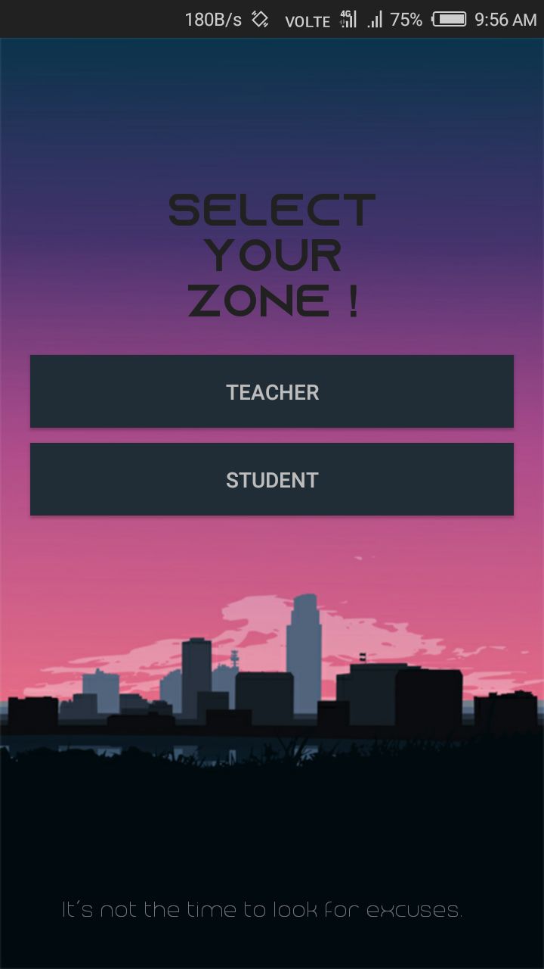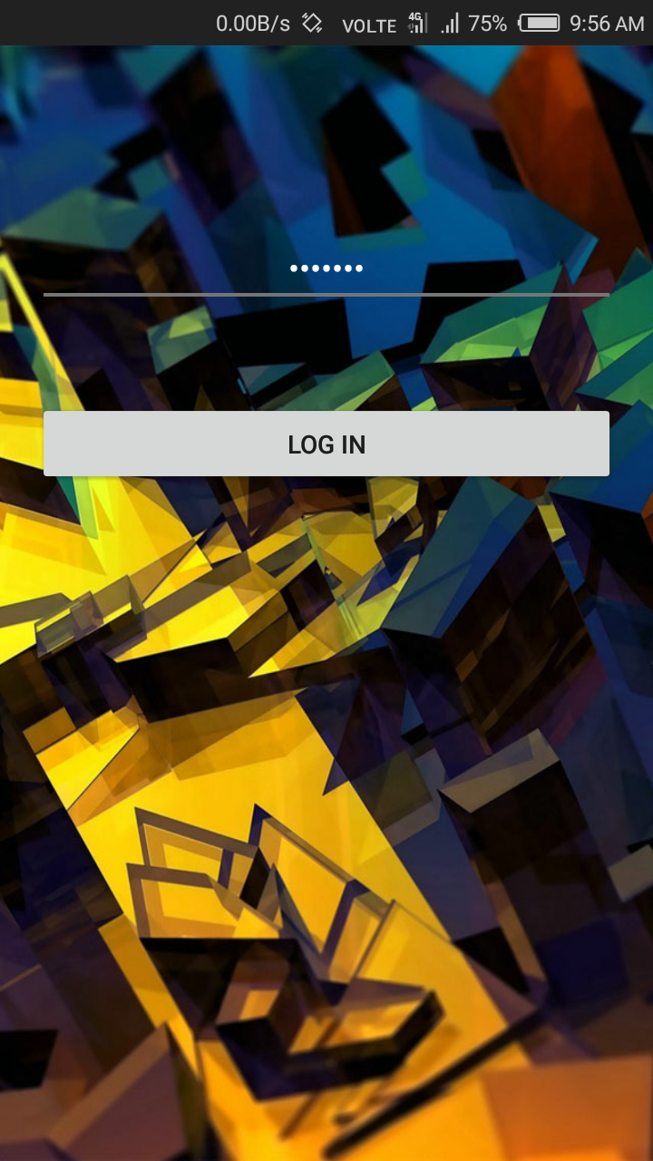

Teacher Login

Main Home activity

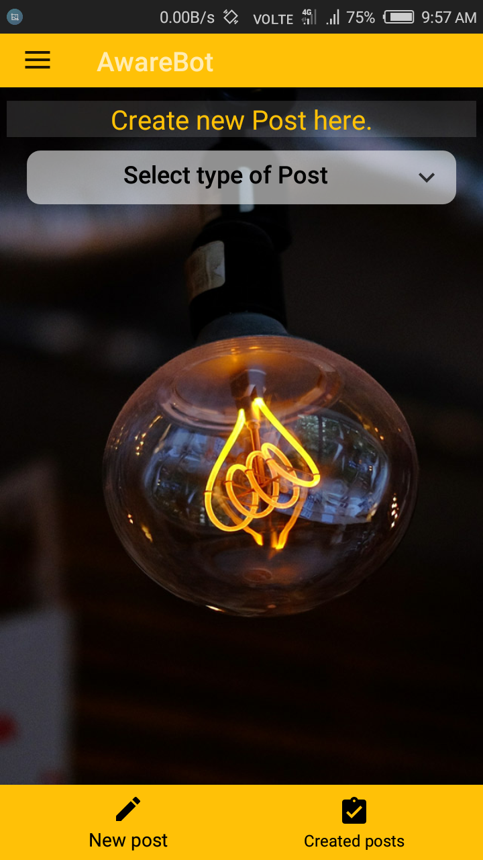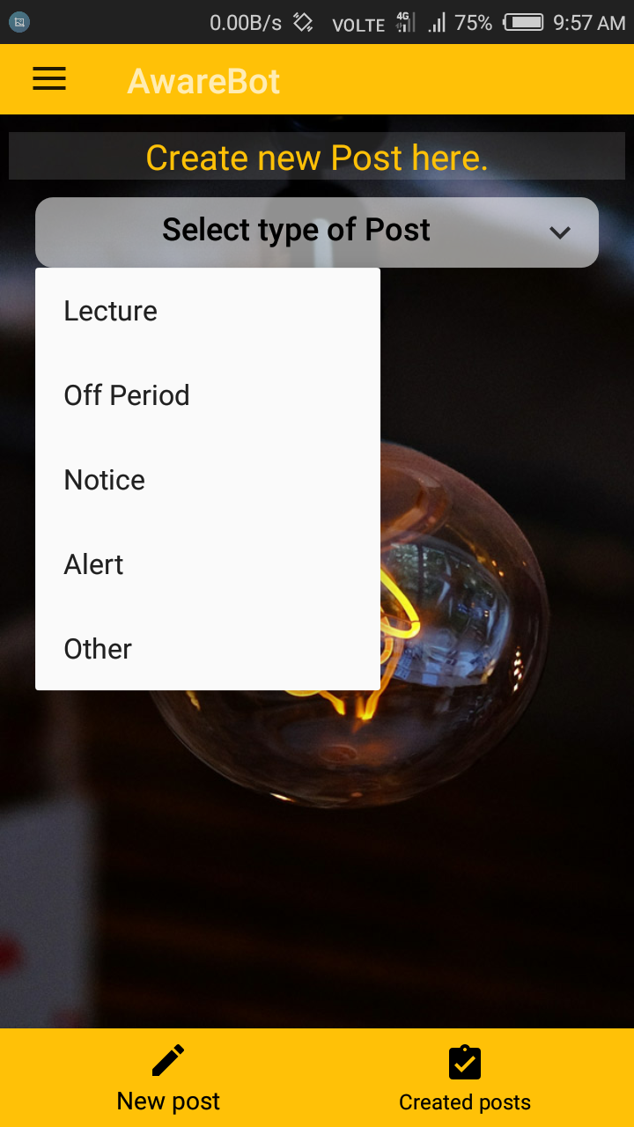

Teacher Home Activity

Post Options

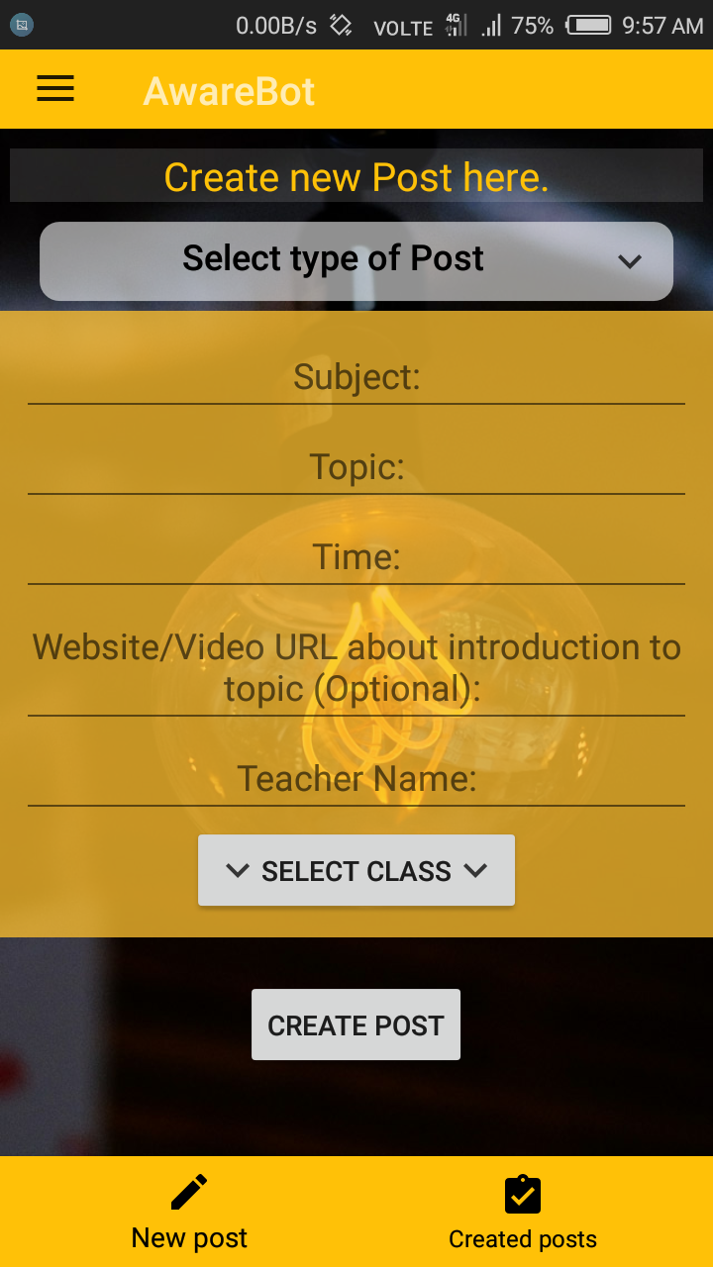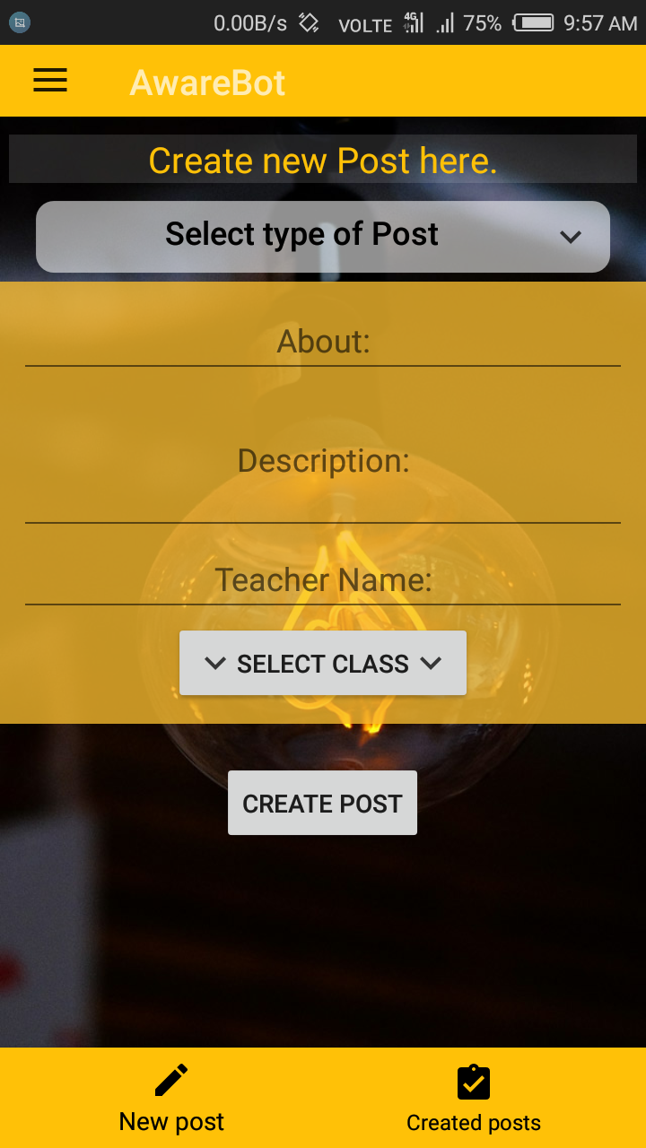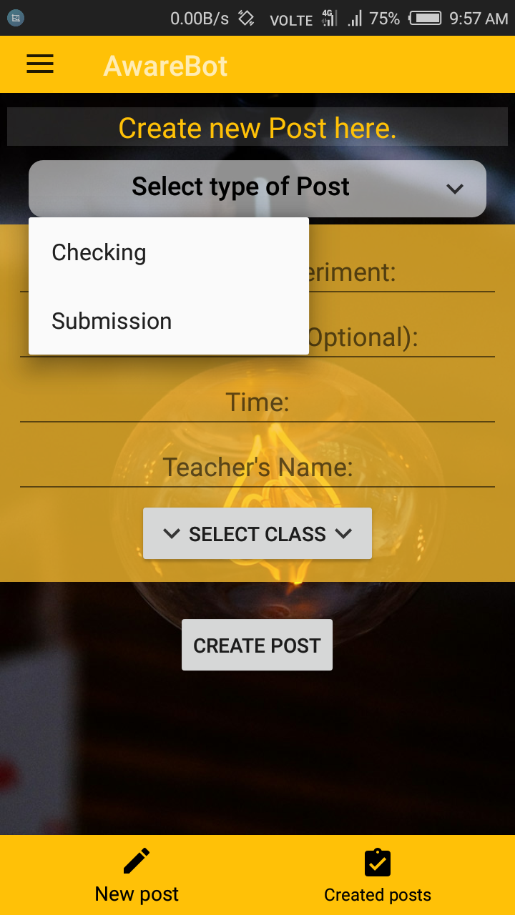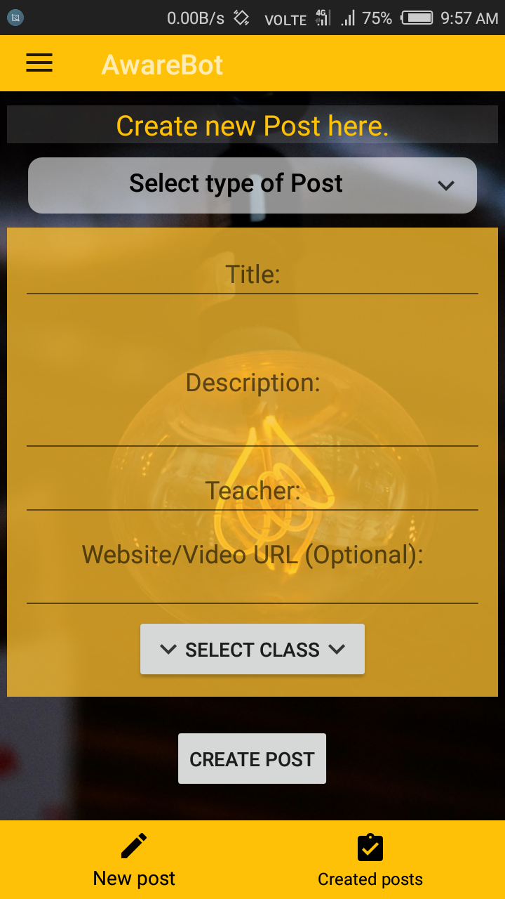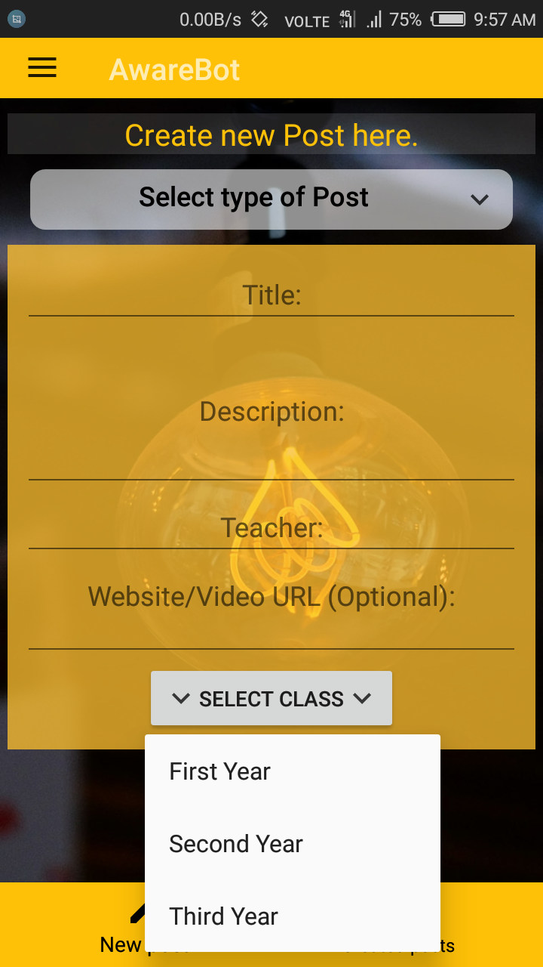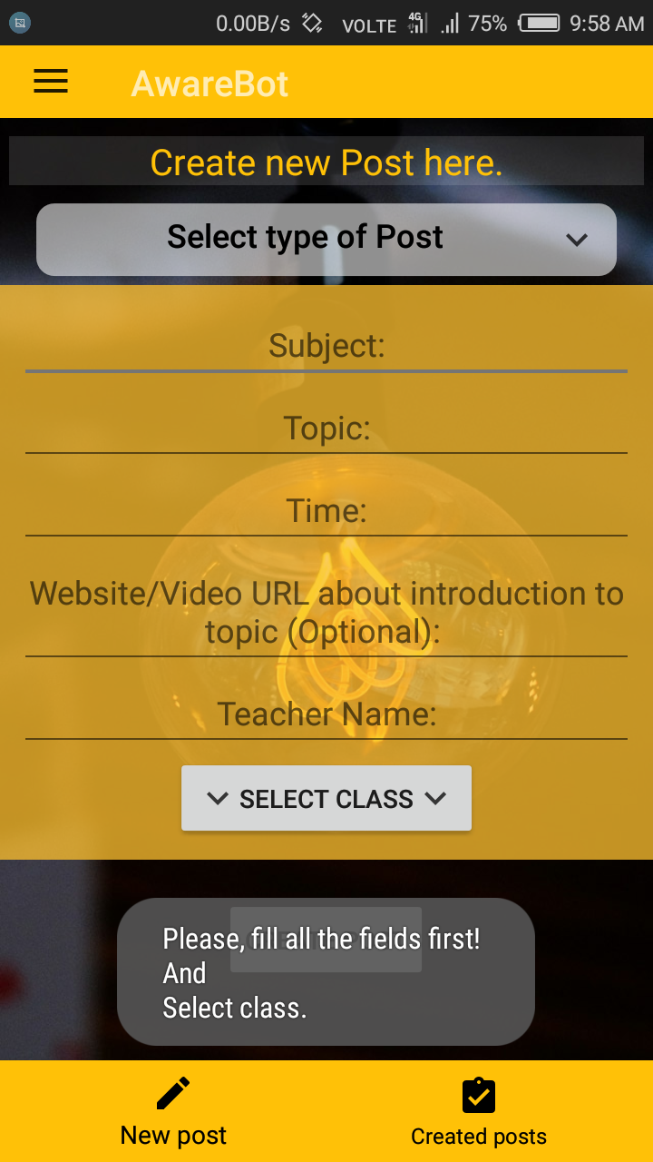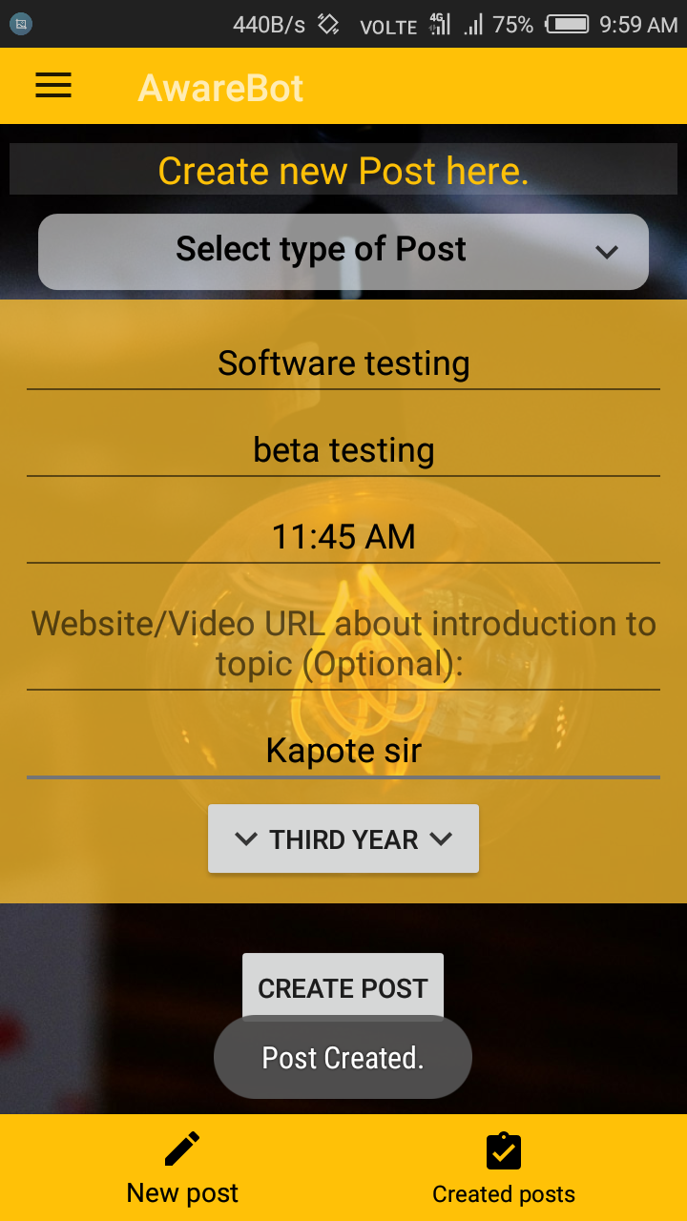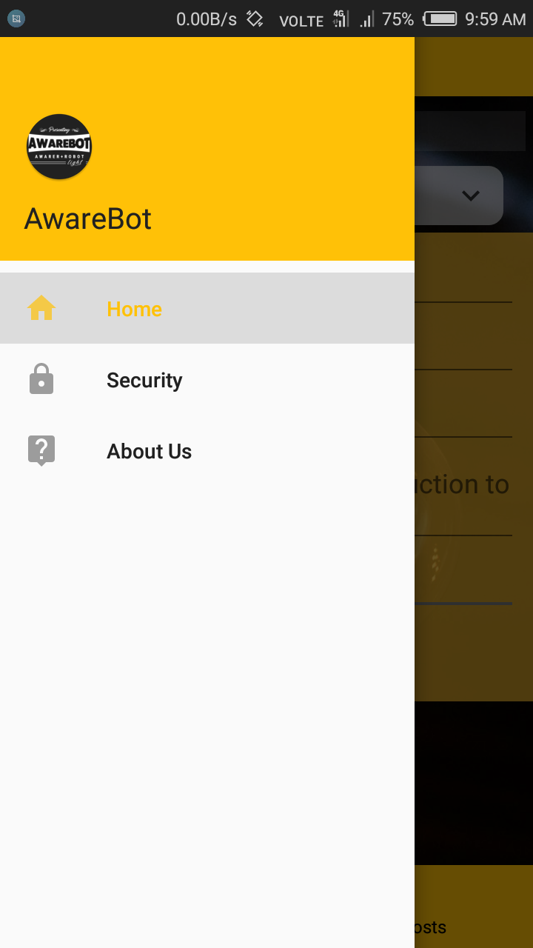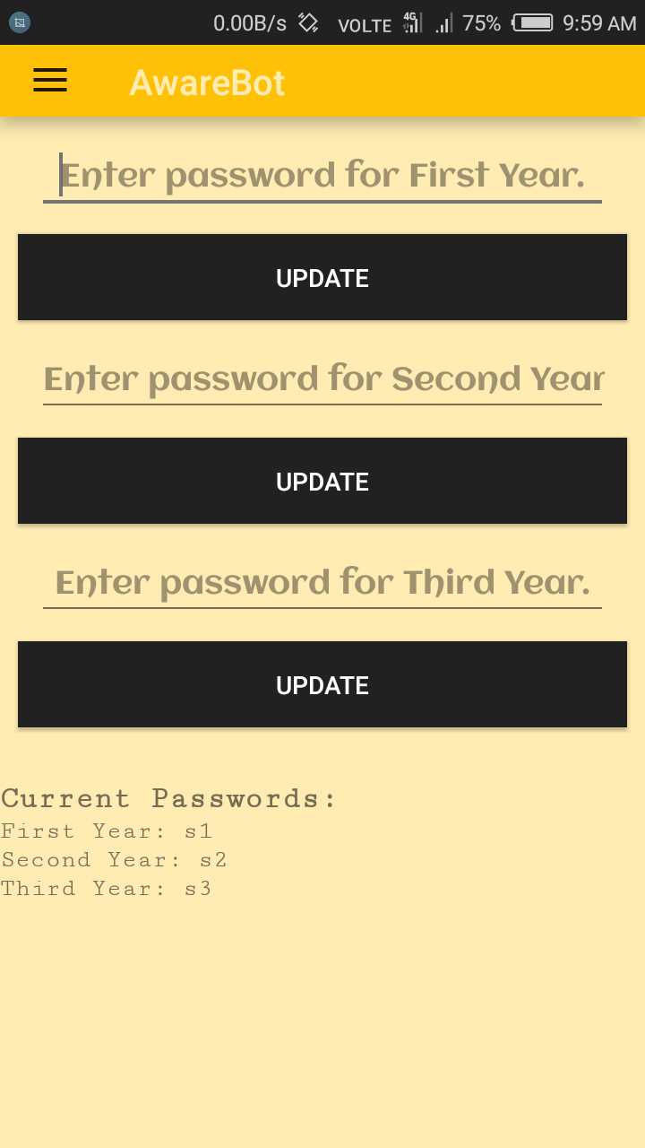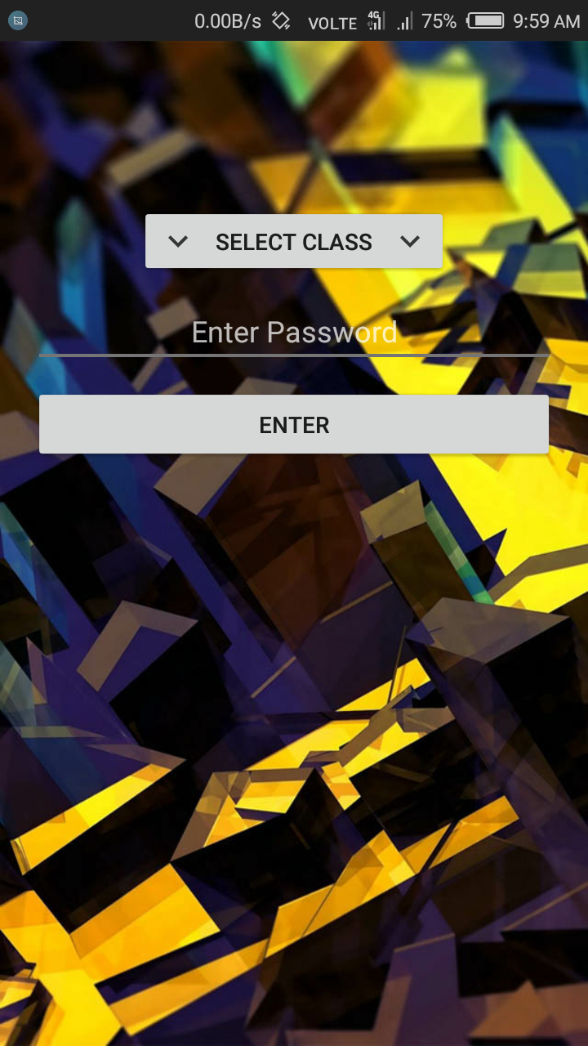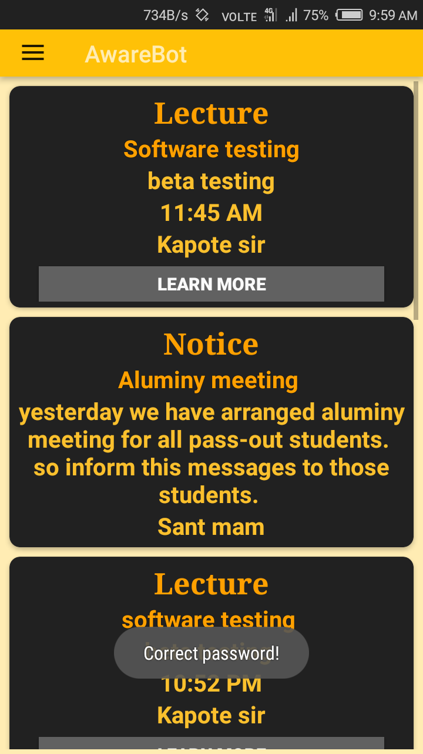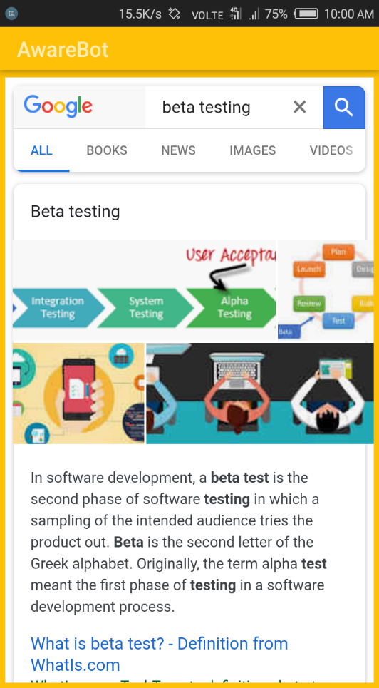

“Notice” option

“Lecture” Option

“Other” option

“Alert” option

Post Audience Selection

Data entry errors management

Application Drawer

Post Creation

Security Fragment

Student Login

Student Home activity

After clicking “Learn More”

Website Snapshots:

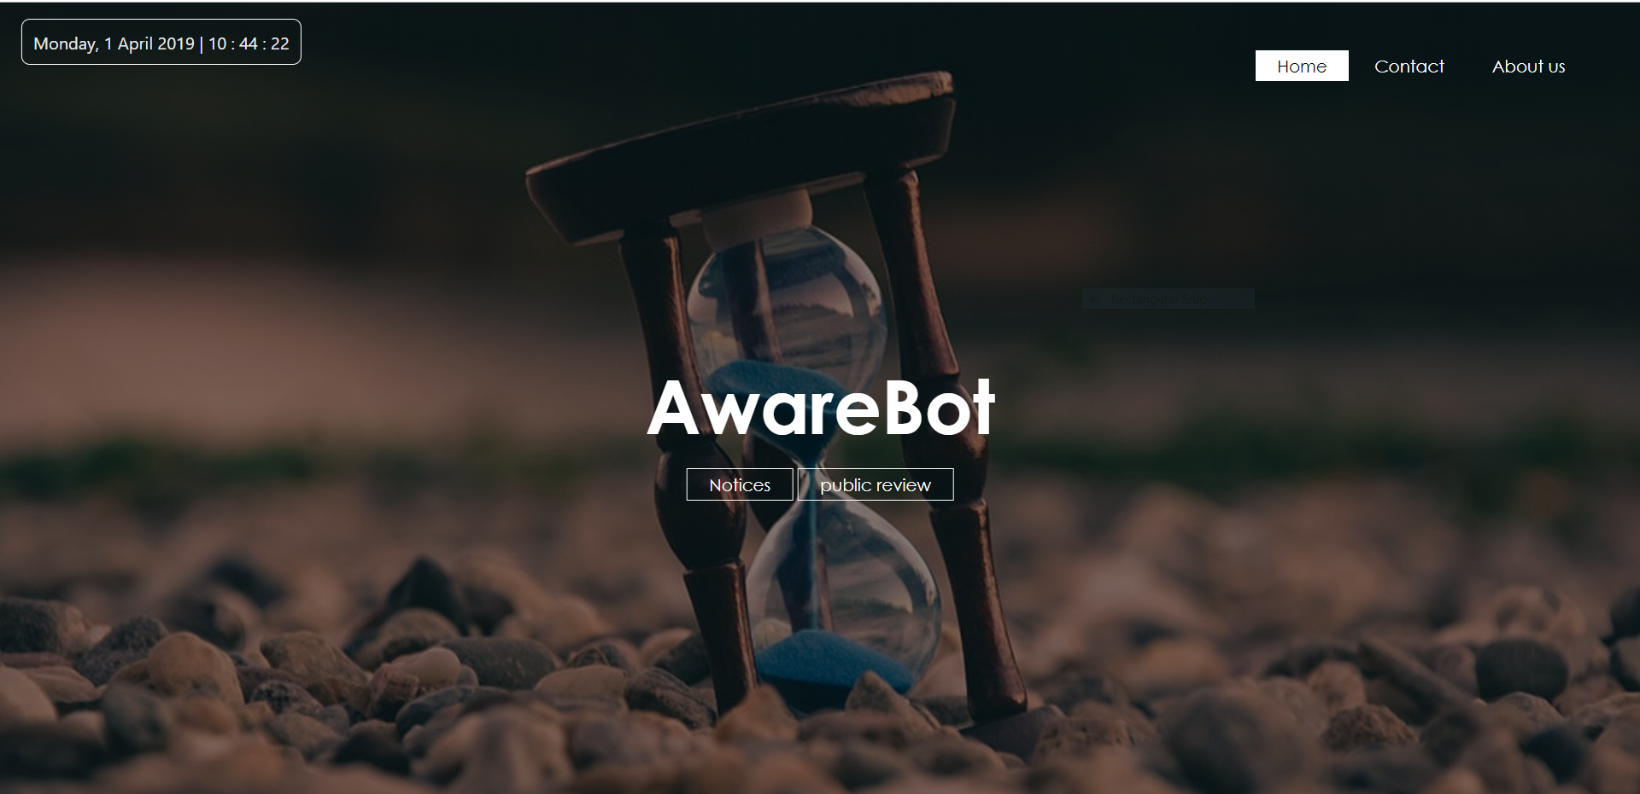

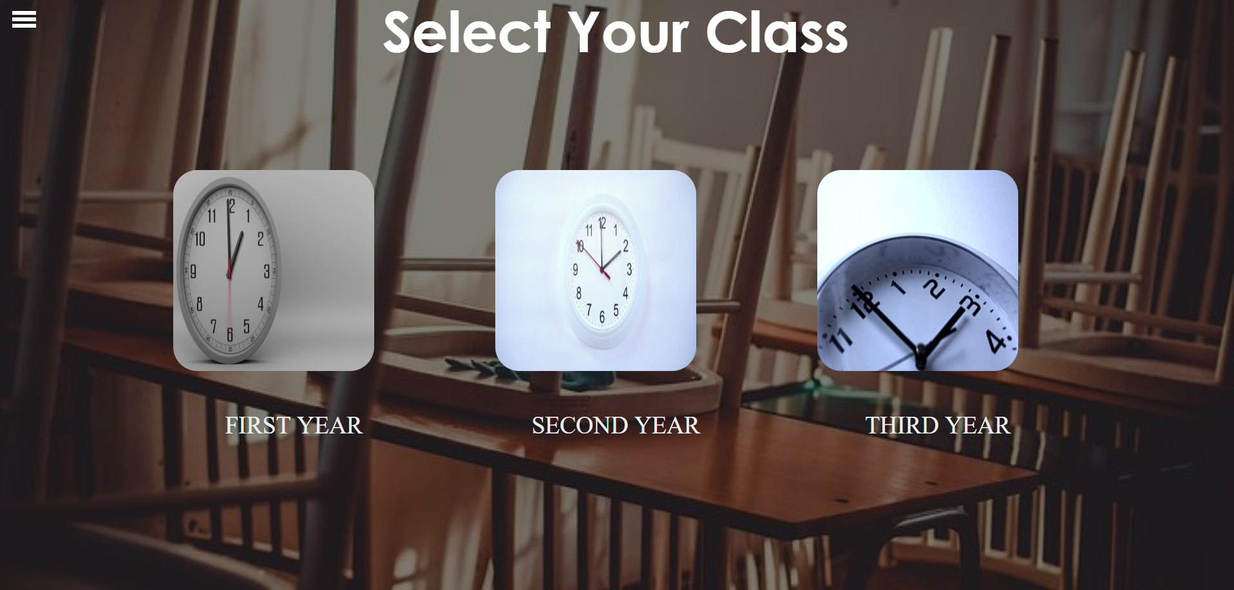

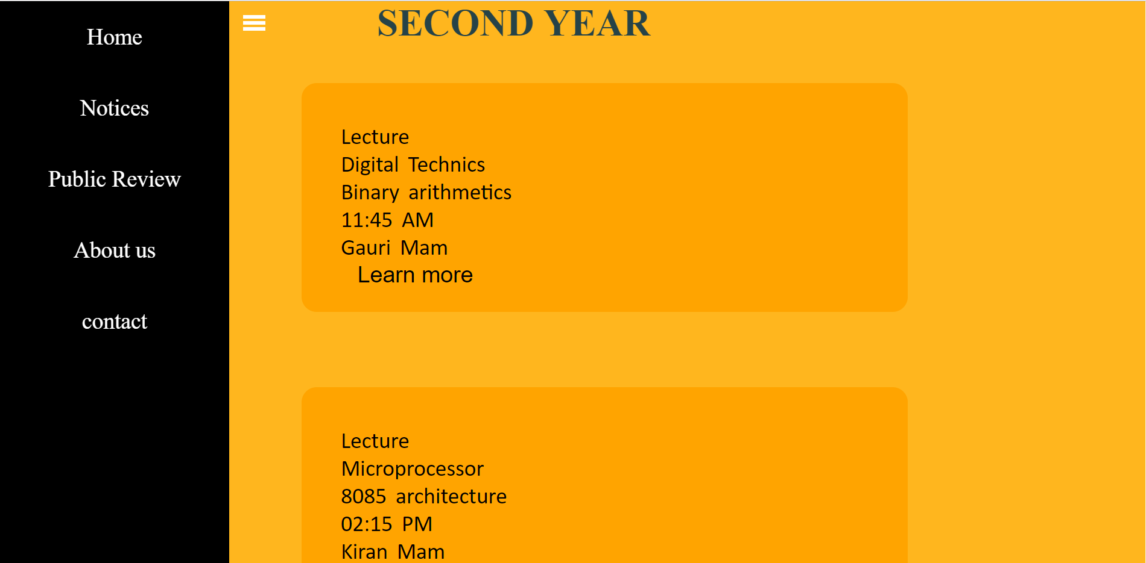

Student Home page

Application database- Firebase database:

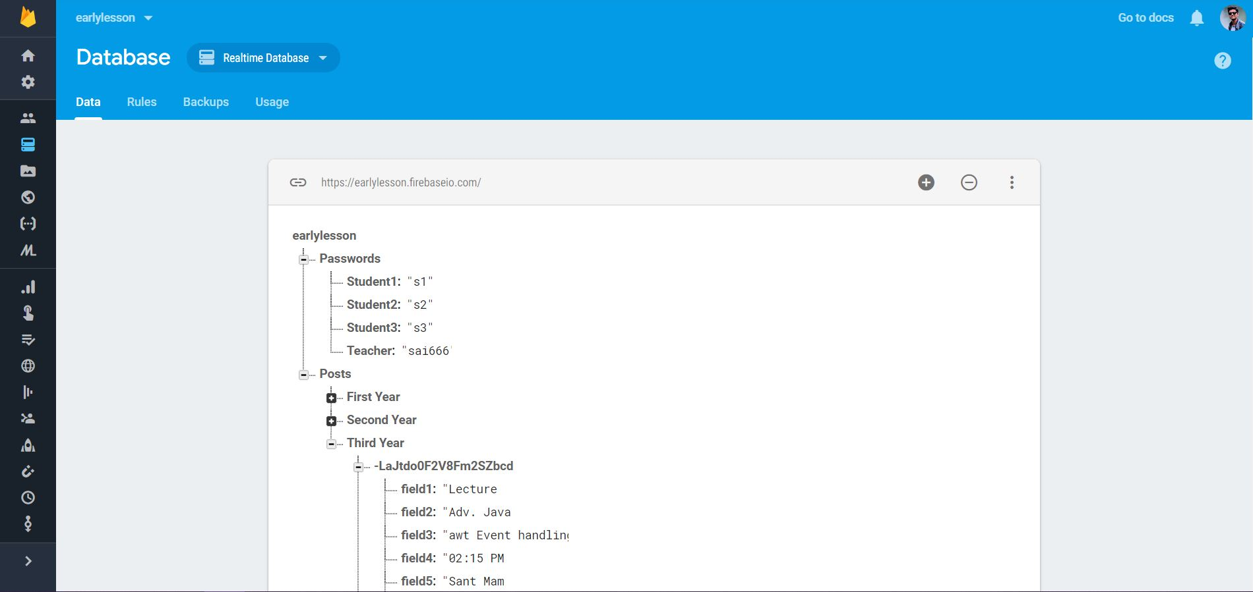

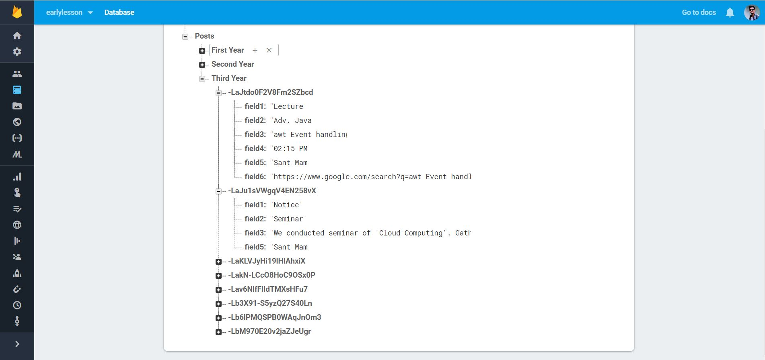

**Code Snapshots:**

Main activity java file:

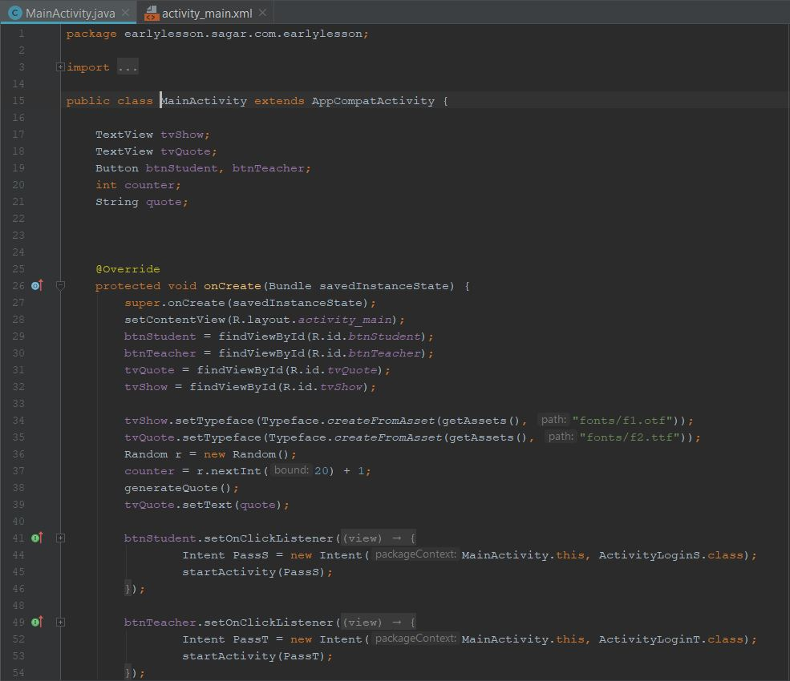

Respective xml file:

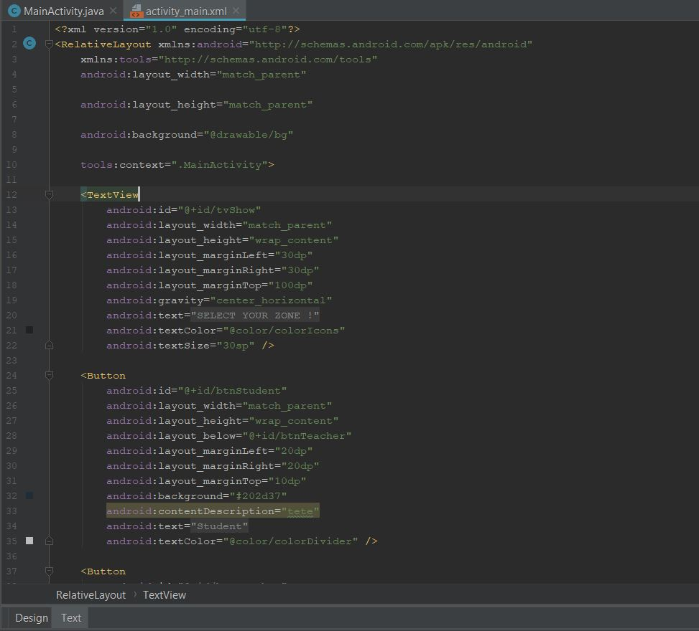

Teacher Home activity java file:

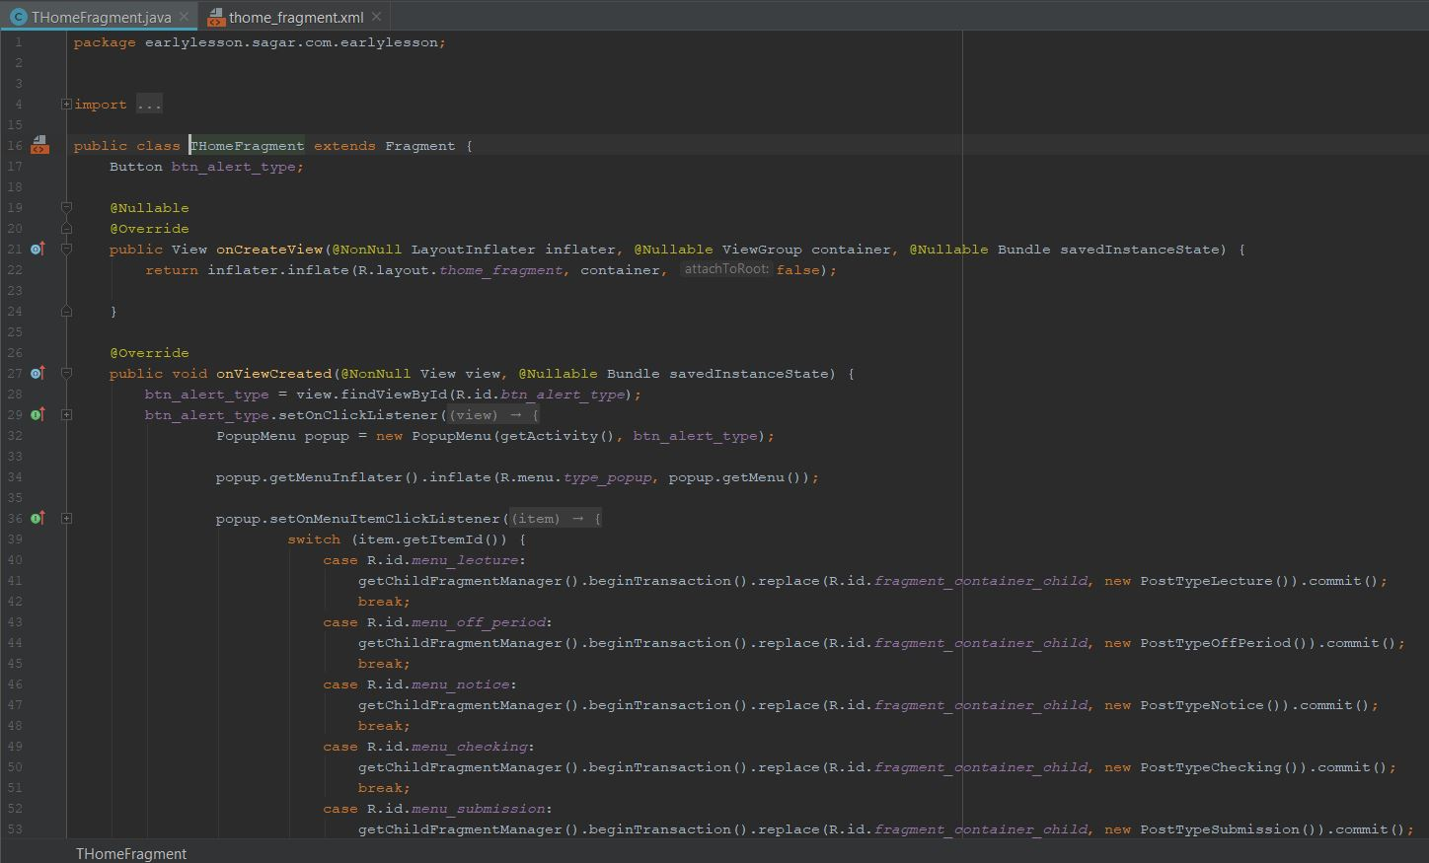

Respective xml file:

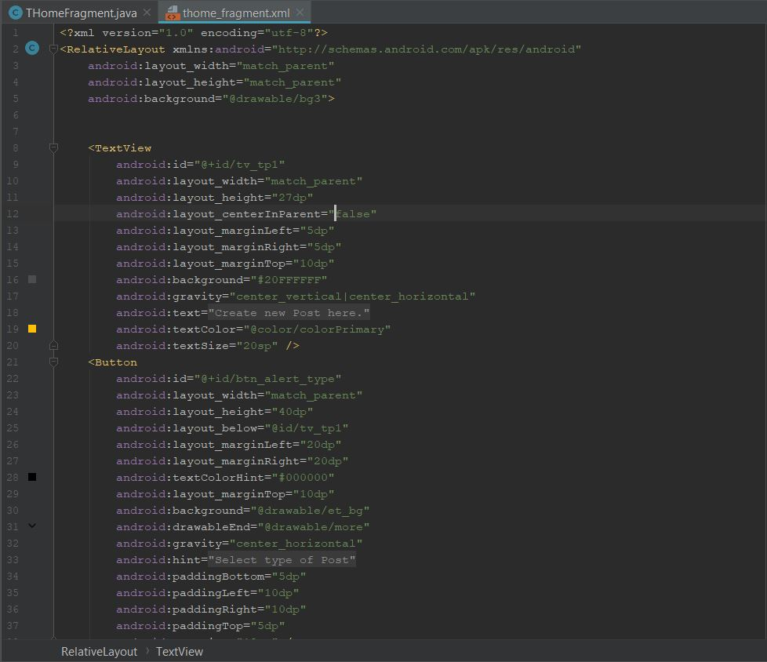

Student Home activity java file:

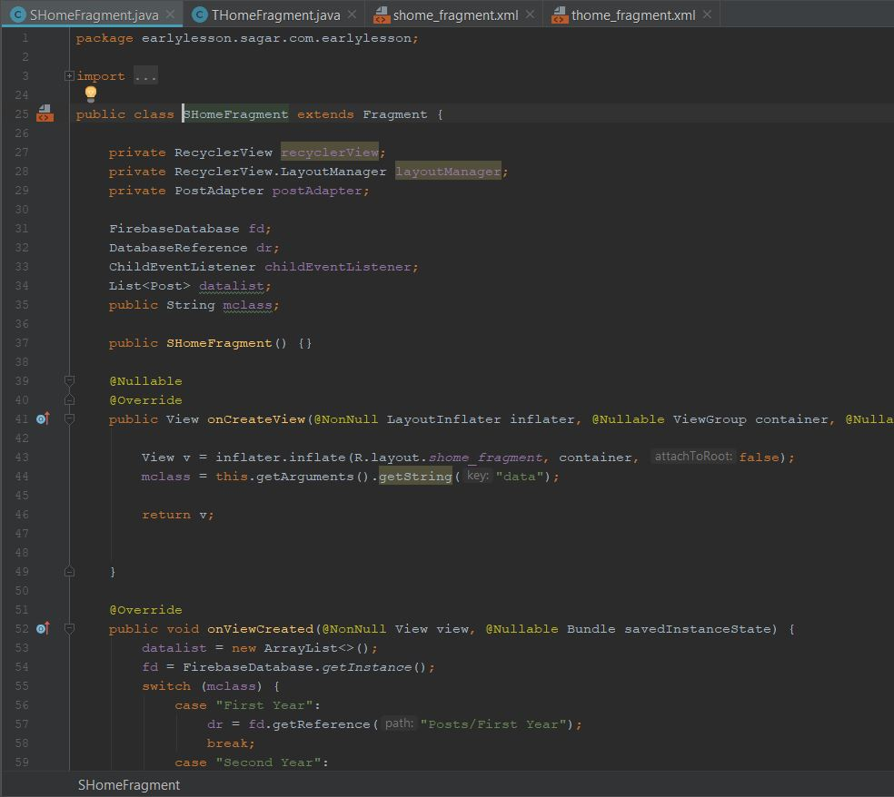

Respective xml file:

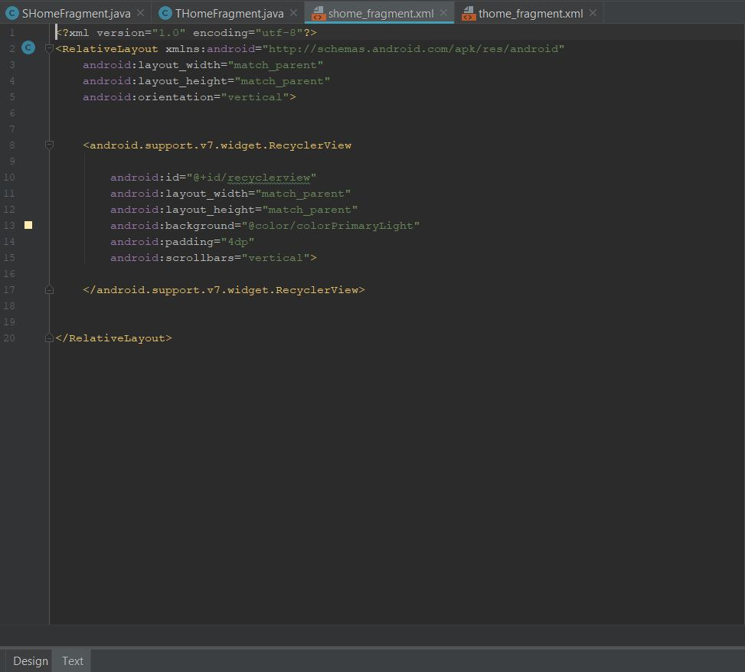

App development were done using IDE -Android Studio:

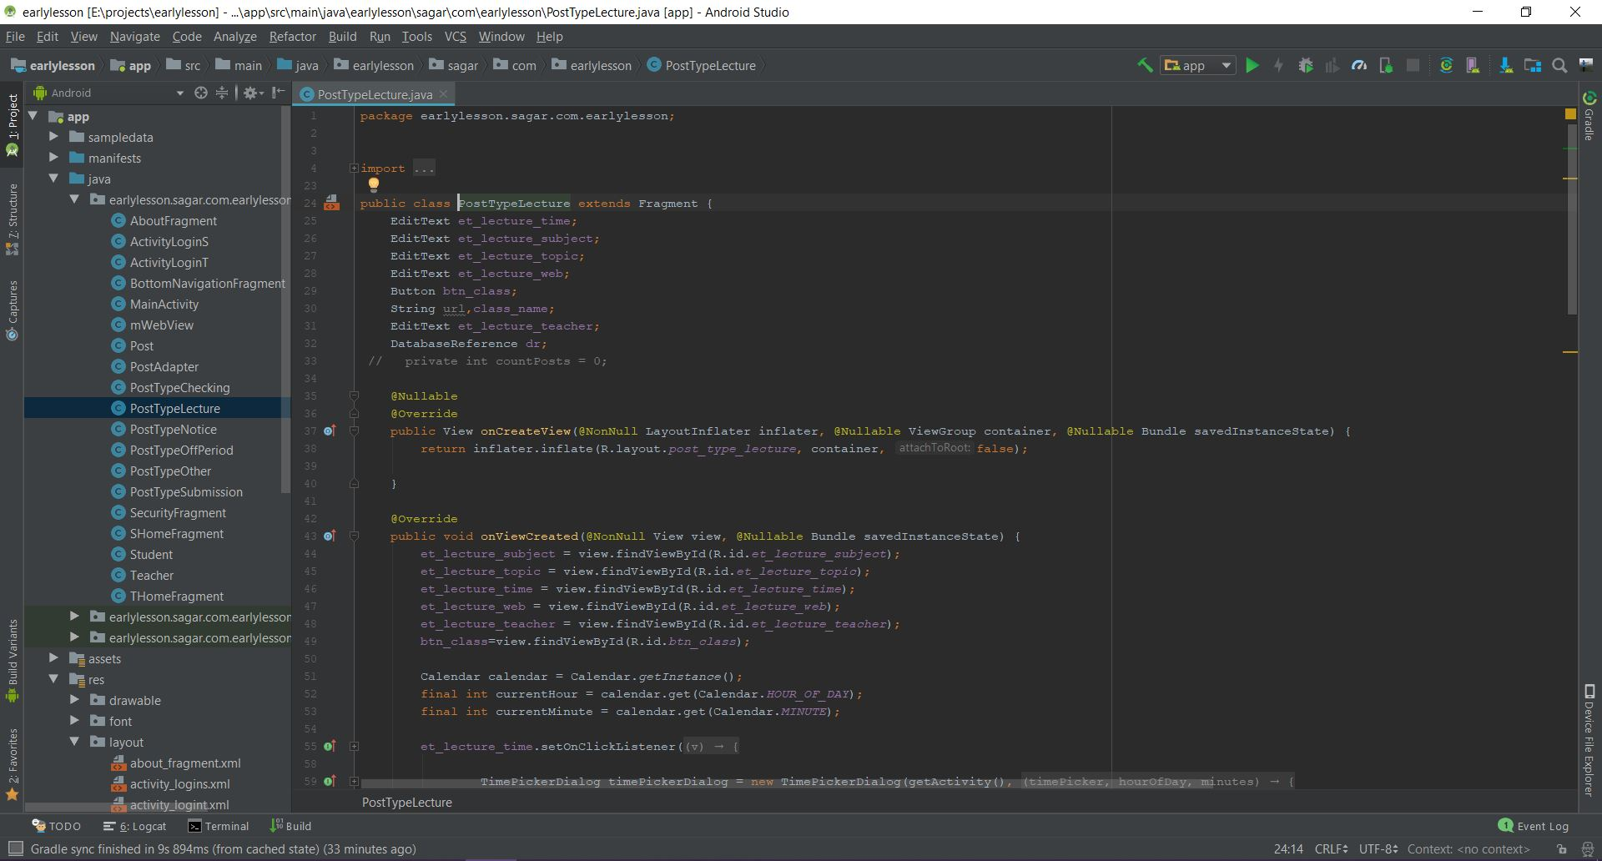

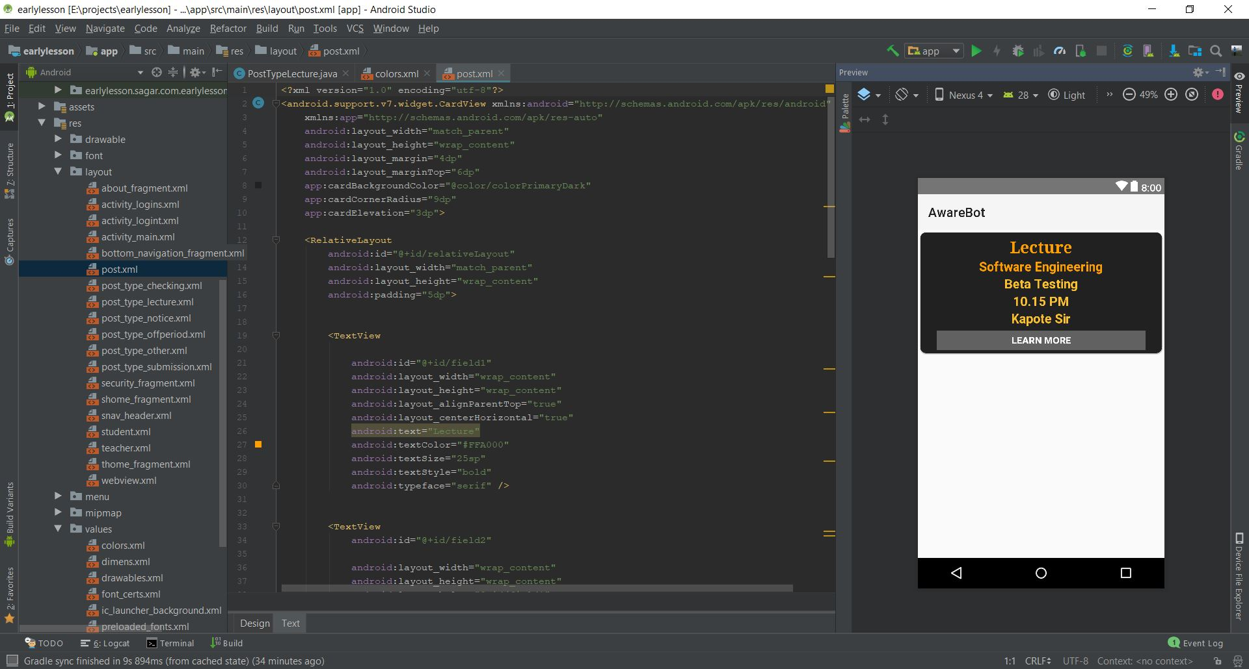

**CHAPTER 9: CONCLUSION AND FUTURE Scope**

**Advantages:**

1. Strong Password Security
2. Game Plan Design security
3. Updating Password
4. Easy to Handling Net Banking
5. Less Time Required Compare that Biometric

**Disadvantages:**

1. Change Mobile Number
2. Network Issue

**Conclusion**:

This project We present a system that gives higher security for NETBANKING transactions. In this system, the color code technique is used. Here, when user’s login takes place successfully he/she is directed to Color Code authentication page. Where the user enters his/her favorite 3 colors in the form of color code generated by system to authenticate whether user is valid or not. If valid then user is redirected to Transaction page where user can carry out his/her own NETBANKING transactions else he/she is directed to login page. In this way by applying the technique of Color Codewe are enhancing the security of login for NETBANKING Transactions, as the attacker don’t know the users favorite colors and even if he/she (attacker) does know those colors, it is not possible to unveil the color code combination which is generated dynamically in our system for carrying out final Authentication process as that color code is encrypted and then sent to user’s personal contact number.

**Future scope**:

1. The addition of Face detection system can be added.
2. The more attractive views can be created.
3. More changes as per owner’s requirements can be added.

**CHAPTER 10: REFERENCES**

[1] Priyanka S. Kedar, Vrunda Bhusari, “Using PBKDF2 Pair & Hybrid technique for Authentication”, International Journal of Emerging Research in Management & Technology (ISSN) 2278-9359, Volume-3, Issue-5, May 2014.

[2] M Shashi, M Anirudh, MD Sultan Ahamer, V Manoj Kumar, “Authentication Schemes for Session Password using colors and Images”, International Journal of Network Security & Its Applications (IJNSA), Vol.3, No.3, May 2011.

[3] Priti Jadhao, Lalit Dole, “Survey on Authentication Password Techniques”, International Journal of Soft Computing and Engineering (IJSCE) ISSN: 2231-2307, Volume-3, Issue-2, May 2013.

[4] Z. Zheng, X. Liu, L. Yin, Z. Liu “A Hybrid password authentication scheme based on shape and text”, Journal of Computers, vol.5, no.5 May 2010.

[5] D.Aruna Kumari, Design, Implementation of Network Based Authentication Mechanisms, Advances in Information Technology and Management, vol.1, no.2, pp.44-48, 2012.

[6] H. Zhao and X. Li, "S3PAS: A Scalable Shoulder- Surfing Resistant Textual-Graphical Password Authentication Scheme," in 21st International Conference on Advanced Information Networking and Applications Workshops (AINAW 07), vol. 2. Canada, 2007, pp. 467-472.

**CHAPTER 11: APPENDIX**

1. Black Book
2. Core Java
3. Android Development
4. Software Engineering
5. Systems Analysis, Design, And Introduction to Software Engineering